**Unit 5 Project Sample:**

**Peaks Design**

**Step 1: Define Audience / Tone**

* **Who will visit your site? Potential employers? New clients or customers?**

Potential clients will visit the site as well as people interested in the company and other people that like the work we do. Peaks design is an architecture firm.

* **What can make you and/or your product stand out against your competitors?**

We are a multi-award winning international architects practice and interior/branding design company. What sets us apart is our work.

* **How would you speak to your clientele if you were communicating in person? How could you translate that style and tone digitally?**

A clean minimalist design, allowing the content to really speak for itself.

* **What colors represent you or your product?**

Greys, whites, and subtle hints of yellow to push the site flow where it should be focused… the content.

* **What images illustrate your message?**

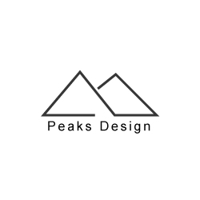

Something simple that I made really quickly, but just to give you something to work.

**Step 2: Define Site Structure**

What are the three-to-five pages titled?

Home(logo should be the home button to free up the nav)

Work

About

News

What will be the purpose for each?

**Homepage**

*Intro to PEAKS!*

Contains:

* Logo (simple, clean imagery.)
* Navigation (present on every page)
* Hero image (finished clients work)
* Footer (contact info and social links - should be present on every page)

**Work**

*Showcasing the finished work to prospective clients and other interested parties.*

Contains:

* Title
* Navigation
* Images
  + Client
  + Description
  + See more link (brings to a new page as to not clutter up the site)

**About**

This is a pretty cut and clear about me section.

* Title
* Navigation
* Images of the creators (blurb under them)(1 is good enough)
* Misson statement
* Blurb about the company.

**News (similar to a blog)**

Here they can learn about the projects that are undertaking at the moment, what’s finished, what’s going on, job opportunities, etc.

* Title
* Navigation
* Body text
* Images to go along with articles.